THE OVERTONES RELEASE NEW ALBUM

10

OUT NOW

LISTEN HERE

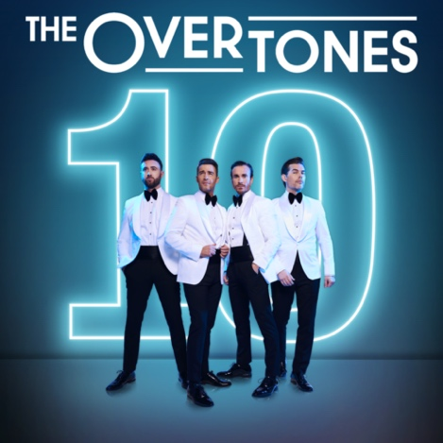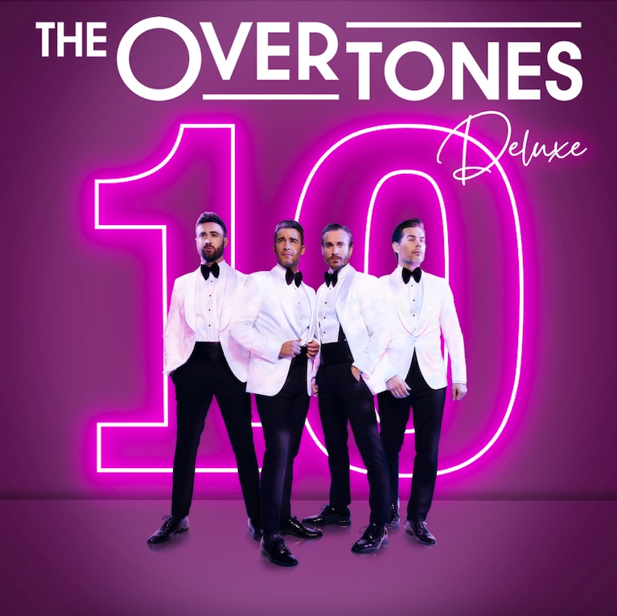

Today The Overtones release their new album, 10, to mark their 10th anniversary. Listen to 10 HERE.

The album features nostalgic hits, original songs and two epic collaborations, including a special cover of Can’t Take My Eyes Off Of You with long-term friend of the band Michael Ball. The second collaboration sees The Overtones reimagine Simply Red’s Stars and features West End star Marisha Wallace. The band also appeared on ITV’s Lorraine this morning to discuss the album, upcoming tour and their 10th anniversary.

The four-piece have also released a deluxe version of the album, with extra tracks, a new neon pink sleeve and an exclusive track by track chat with the band. The album is available in 5 formats – CD, Digital, Cassette, Deluxe Digital and Deluxe CD and can be purchased/streamed HERE.

Speaking about the 10th anniversary, The Overtones say: “2021 is all about bringing back the feel good and that's what The Overtones do best. As we celebrate the past, dance in the present and sing for the future, we are so excited and blessed to release 10 and give The Overtones family their best night yet on our forthcoming tour!”
The 4-piece most recently released their third single from the upcoming album in the form of summery track Rose Tinted. You can watch the official video HERE. Rose Tinted follows on from a special re-recording of their debut hit Gambling Man, watch the video here and a brilliant cover of Shalamar’s A Night To Remember, listen here.

The band recently did a livestream on their YouTube and Facebook to mark Men’s Health Week, 7 days to raise awareness of the health issues that affect men disproportionately and with a focus on getting men to become more aware about the health problems they have or could develop, to talk about their health more and then do something about it. During the livestream, they discussed a varied range of subjects from depression, fatherhood, vasectomies, anxiety, grief, sexuality, financial pressures and the importance of fitness. They hoped to use the live stream as an opportunity to build conversation about what helps and hinders men’s health and why. You can watch the livestream back here.

Since bursting onto the UK music scene ten years ago, The Overtones have racked up platinum record sales, released 6 studio albums, scored four Top 10’s, sold out tours across the nation, performed for Her Majesty The Queen at Buckingham Palace and sang to one million people at the Brandenburg Gate in Berlin. They have firmly established themselves as one of the UK’s most popular live acts, best known for their exquisite vocals, distinctive style, charm and perfectly-pitched harmonies.
The Overtones are Mark Franks, Darren Everest, Jay James and Mike Crawshaw.
THE OVERTONES 10 TRACKLISTING
Standard Album
1. Gambling Man 2.0
2. Can't Take My Eyes Off Of You (Feat. Michael Ball)
3. Celebration
4. Amigo
5. Stars (Feat. Marisha Wallace)
6. Build Me Up Buttercup
7. A Night to Remember
8. Signed, Sealed, Delivered (I'm Yours)
9. Rose Tinted
10. Reach Out (I'll Be There)
11. September (Live)
12. You to Me Are Everything (Live)

Deluxe Album
1. Gambling Man 2.0
2. Can't Take My Eyes Off Of You (Feat. Michael Ball)
3. Celebration
4. Amigo
5. Stars (Feat. Marisha Wallace)
6. Build Me Up Buttercup
7. A Night to Remember
8. Signed, Sealed, Delivered (I'm Yours)
9. Rose Tinted
10. Reach Out (I'll Be There)
11. September (Live)
12. You to Me Are Everything (Live)
13. Amazing Grace
14. A Night To Remember (Acoustic)
15. I’m Gonna Be (500 Miles)
16. The Ten Year Story + Track by Track (Chat & Discussion)

THE OVERTONES 10th ANNIVERSARY 2021 TOUR DATES

9TH Nov Halifax, Victoria Theatre
10th Nov Llandudno, Venue Cymru
11th Nov Scunthorpe, Baths Hall
13th Nov Bath, The Forum
14th Nov Bournemouth, Pavilion Theatre
19th Nov Northampton, Derngate
20th Nov Colchester, Charter Hall
21st Nov Cambridge, Corn Exchange
22nd Nov Birmingham, Symphony Hall
25th Nov Worthing, Assembly Hall
26th Nov Plymouth, Pavilions
27th Nov Basingstoke, Anvil
28th Nov Bexhill, De La Warr Pavilion
30th Nov Manchester, Bridgewater Hall
1st Dec Stoke, Victoria Hall
2nd Dec London, Indigo2
8th Dec Glasgow, Royal Concert Hall
10th Dec York, Barbican
11th Dec Newcastle, City Hall
12th Dec Sheffield, City Hall

To purchase tickets, please visit https://premier.ticketek.co.uk/shows/show.aspx?sh=THEOVERT21.

Follow The Overtones at:
Online - http://www.theovertones.tv/
Facebook - https://www.facebook.com/theovertones/
Instagram - https://www.instagram.com/the_overtones/
Twitter - https://twitter.com/the_overtones
YouTube - https://www.youtube.com/c/theovertones/about
MusicGlue - https://www.musicglue.com/the-overtones/
Spotify - https://open.spotify.com/artist/6dXTZ

For more information on The Overtones, please contact lauren@halestormpr.com.

