

TEG MJR PRESENT
The Overtones
Celebrate the release of ‘Can’t Take My Eyes Off Of You’ featuring Michael Ball from their No.1 album
&
10th Anniversary Tour
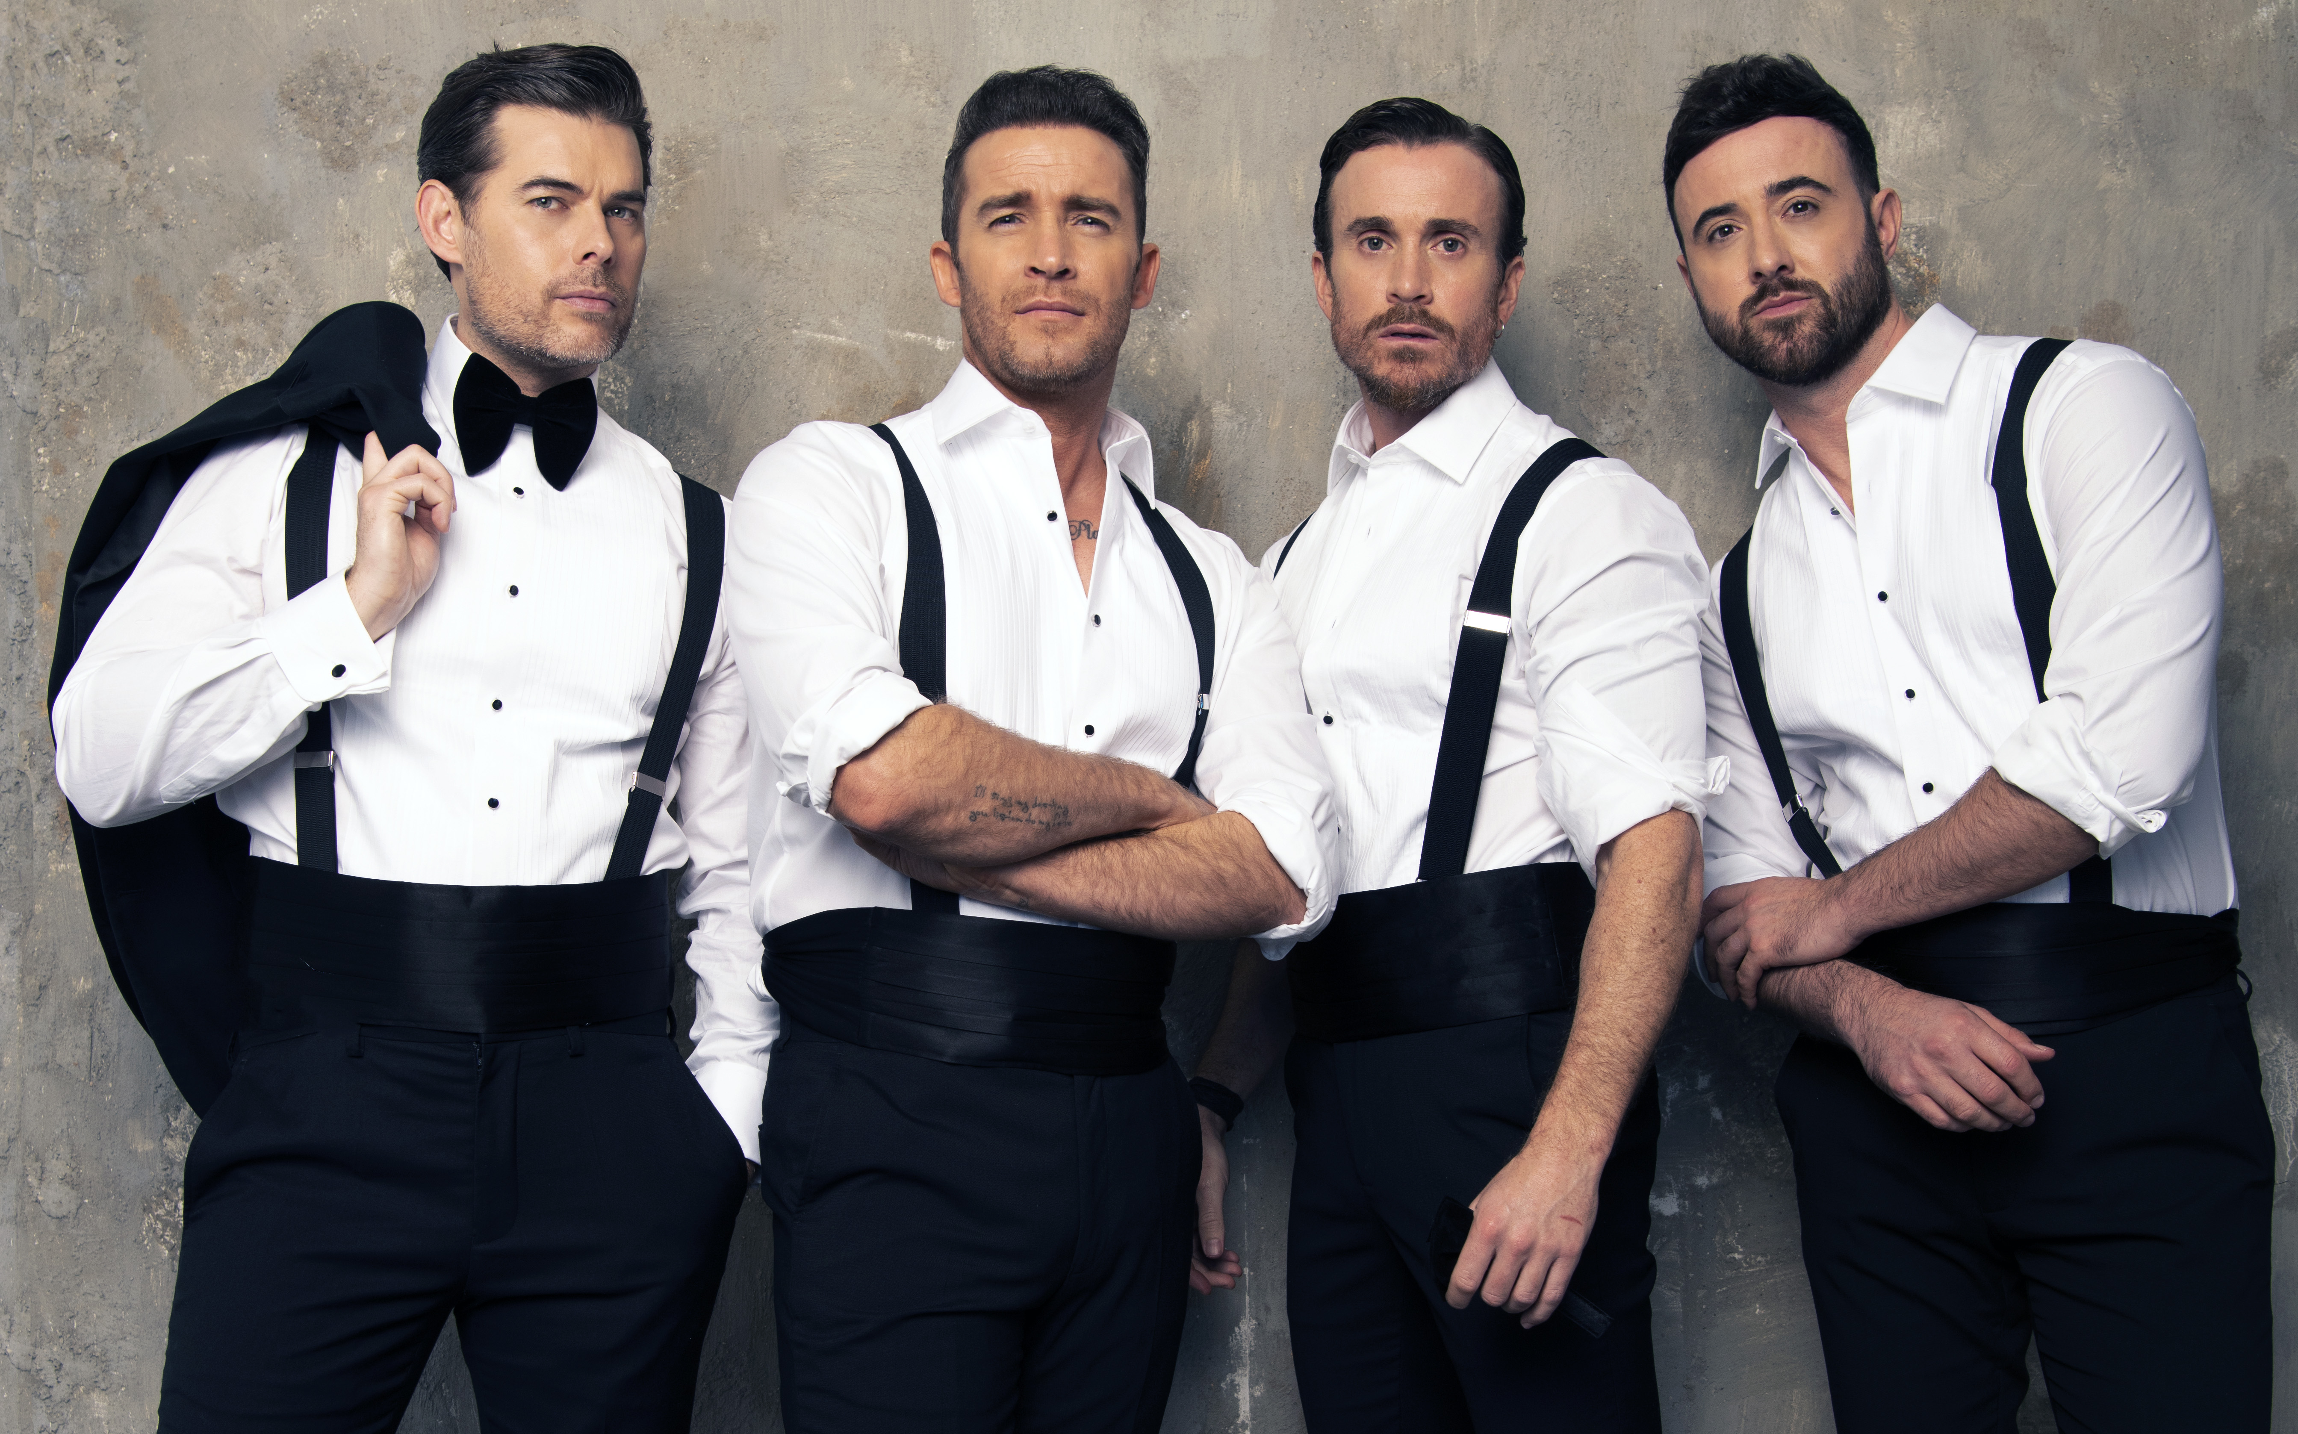
with free tickets for Ukrainian refugees

The multi-platinum selling group are set to bring back the feel good as they tour the UK next month celebrating 10 years as one of the country’s most prolific live acts. Last summer saw their ‘10’ album reach number 1, featuring Marisha Wallace & Michael Ball who features on ‘Can’t Take My Eyes Off Of You’ which is available now.

The band have also launched a campaign giving away 250 free tickets to Ukrainian refugees and their host families in the UK.

TICKET LINK: https://premier.ticketek.co.uk/shows/show.aspx?sh=THEOVERT21

PRESS ASSETS:
https://www.dropbox.com/sh/hd2zk1nx0kctjm0/AADSZ58GVlYctH8I8AsUpP6Ia?dl=0

BAND PHOTOS: https://drive.google.com/drive/folders/14TucDzJ6u1rUAfNdsVB2CUOgRqcNwG45

Since bursting onto the UK music scene ten years ago, The Overtones have racked up platinum record sales, released 6 studio albums, sold out tours across the nation, and performed for Her Majesty The Queen firmly establishing them as one of UK’s most popular live acts best known for their exquisite vocals and distinctive style.
The band have previously headlined some of the UK & Europe’s most prestigious venues including The London Palladium, The Royal Albert Hall - and achieving standout performances at Buckingham Palace for the Queen’s Diamond Jubilee and singing to one million people at the Brandenburg Gate in Berlin. The Overtones marked their tenth anniversary with a number 1 album (10) and finally embarking on their rescheduled (from 2020) tour dates in 2022.
As a gesture of support & welcome for Ukrainian refugees, the band launched a social media campaign on April 19th giving away 250 tickets to refugees in the UK to attend their shows across the country. The offer also extends to any host families who have opened their homes to refugees throughout the Ukraine crisis. The application is very simple, those who would like to attend apply online via https://bit.ly/OvertonesUkraineTickets and the first 250 applicants will be added to the bands guestlist in their requested tour town. The band have partnered with Tickets For Good, who will be supporting the campaign by reaching out to various Ukrainian charities in the UK.

Mark, Darren, Jay and Mike have mastered the perfect mix of originality with classic nostalgia, and combined with their charm and perfectly-timed dance moves - and of course their perfectly-pitched harmonies - their effortless performances and style have helped deliver their sell out successes across the globe during the past decade.
Having experienced loss, parenthood and a new line up during this time, the multi-talented awesome foursome have never been closer and continue to perfect their craft for their adoring fans.
In 2019 the group welcomed new member, Jay James - who also became a household name after working with musicians like John Legend and becoming a finalist on The X Factor - and saw the start of an exciting new era for the boys who went on to sell out their 10th consecutive UK tour.
Speaking about the 10th anniversary of the band, Jay says “2022 is all about bringing back the feel good and that's what The Overtones do best. As we celebrate the past, dance in the present and sing for the future, we are so excited and blessed to give The Overtones family their best night yet!”
Like many other acts, the last 2 years have meant cancelled tours and releases for The Overtones, but with a newly recharged band and an excitement of what’s to come in their anniversary year, the group can’t wait to be back on the road in 2022.

Mark Franks said, “We can’t wait to finally get to sing, dance & party together with you all, in 2022, on our 10 Year Anniversary Tour. It’s been a long time coming and there really ain’t no party like an Overtones party!”

The group also celebrate their official tour tune ‘Can’t Take My Eyes Off Of You’ featuring Michael Ball, taken from their number 1 selling album ‘10’ last summer. Listen here: https://slinky.to/TenDeluxeEdition

The Overtones and Michael Ball have shared a longstanding friendship, and the band have recently announced that they will be extending their 10th Anniversary tour celebrations over the summer by joining Michael on his upcoming ‘Together This Summer’ tour alongside Alfie Boe."

THE OVERTONES 10th ANNIVERSARY TOUR DATES 2022

22nd May Halifax, Victoria Theatre
23rd May Manchester, Bridgewater Hall
24th May Birmingham, Symphony Hall
26th May Scunthorpe, Baths Hall
27th May Bexhill, De La Warr Pavilion
29th May Bournemouth, Pavilion Theatre
30th May Cambridge, Corn Exchange
31st May Basingstoke, The Anvil
2nd Jun Colchester, Charter Hall
3rd Jun Plymouth, Pavilions
5th Jun London, Indigo2
6th Jun York, Barbican
7th Jun Newcastle, O2 City Hall

For further information, interviews & review guestlist:
Gemma Cutting 07769 700400/ gemmahushpr@gmail.com
Sacha Taylor-Cox 07957 338525/ sacha@hushhushpr.co.uk

